OCR Test Document
Driver License Image + Dummy PII Data

Section 1: Embedded Document Image
The image below is embedded — OCR tools will attempt to extract text from it.

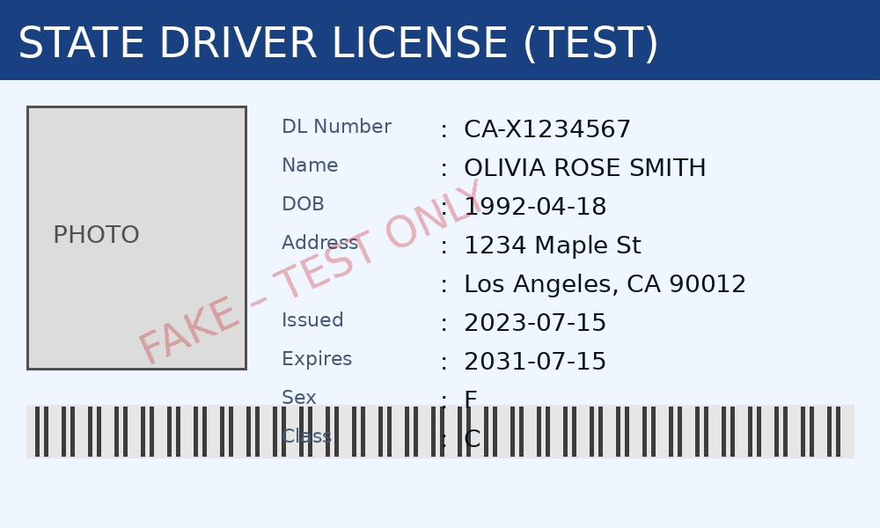

Section 2: Typed Structured Data (Selectable Text)
This table contains typed/selectable text for OCR accuracy comparison.

Field | Value
Name | Priya Sharma
DOB | 15/08/1990
Phone | +91 9876543210
Email | priya.sharma@example.in
Aadhaar | 2345 6789 0123
PAN Card | ABCPS1234A
Bank Account | 3456789012
IFSC | HDFC0001234
Address | 12 MG Road, Bengaluru, KA 560001
Voter ID | KAR1234567

Section 3: Free-form Text Block
Applicant Rahul Verma (PAN: BCDRV5678B, Aadhaar: 3456-7890-1234) has submitted a KYC request. Mobile: +91 9123456780. Address: 45 Park Street, Mumbai 400001. Bank IFSC: SBIN0002345, Account: 4567890123. This block tests OCR performance on continuous unstructured prose.

NOTE: All data is synthetic and intended for OCR/PII detection testing only. No real individuals are represented.

